CV LAB EXPERIMENTS (21-40)

Experiment 21: Morphological Opening
Code
import cv2
import numpy as np
img = cv2.imread(r"C:\Users\T Rohita Sai\Downloads\cute puppy.jpg")
kernel = np.ones((5,5), np.uint8)
opening = cv2.morphologyEx(img, cv2.MORPH_OPEN, kernel)
cv2.imwrite(r"C:\Users\T Rohita Sai\Downloads\opening_output.jpg", opening)
cv2.imshow("Opening", opening)
cv2.waitKey(0)
cv2.destroyAllWindows()
OUTPUT:

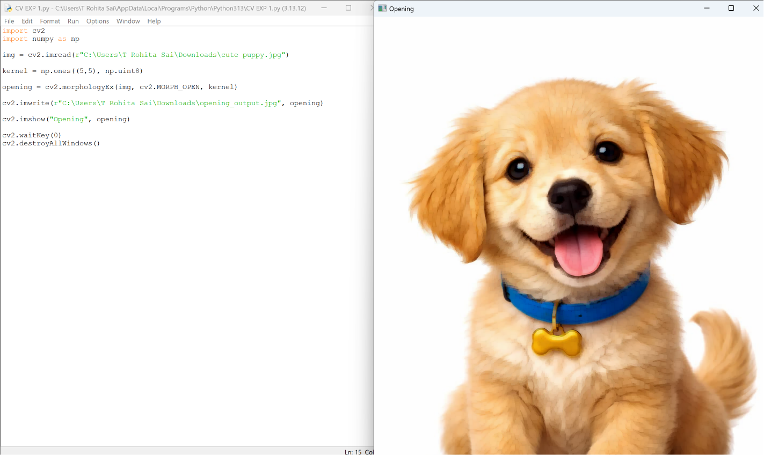
Experiment 22: Morphological Closing
Code
import cv2
import numpy as np
img = cv2.imread(r"C:\Users\T Rohita Sai\Downloads\cute puppy.jpg")
kernel = np.ones((5,5), np.uint8)
closing = cv2.morphologyEx(img, cv2.MORPH_CLOSE, kernel)
cv2.imwrite(r"C:\Users\T Rohita Sai\Downloads\closing_output.jpg", closing)
cv2.imshow("Closing", closing)
cv2.waitKey(0)
cv2.destroyAllWindows()
OUTPUT:
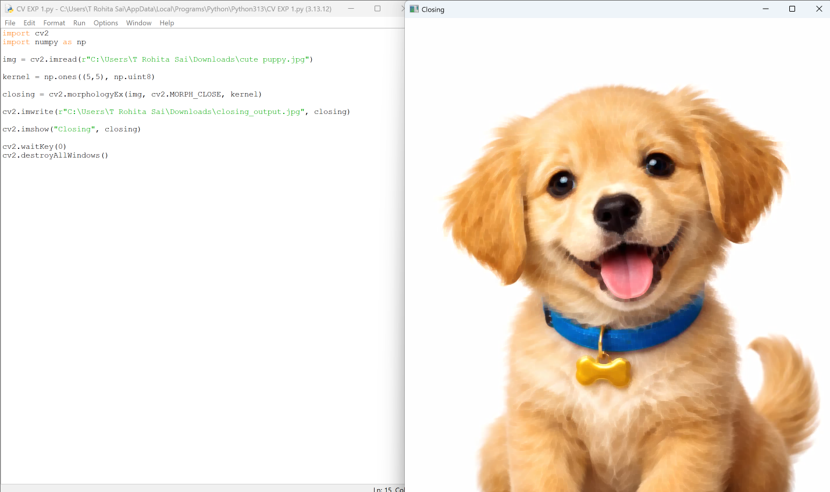

Experiment 23: Top Hat Transformation
Code
import cv2
import numpy as np
img = cv2.imread(r"C:\Users\T Rohita Sai\Downloads\cute puppy.jpg")
kernel = np.ones((9,9), np.uint8)
tophat = cv2.morphologyEx(img, cv2.MORPH_TOPHAT, kernel)
cv2.imwrite(r"C:\Users\T Rohita Sai\Downloads\tophat_output.jpg", tophat)
cv2.imshow("Top Hat", tophat)
cv2.waitKey(0)
cv2.destroyAllWindows()
OUTPUT:
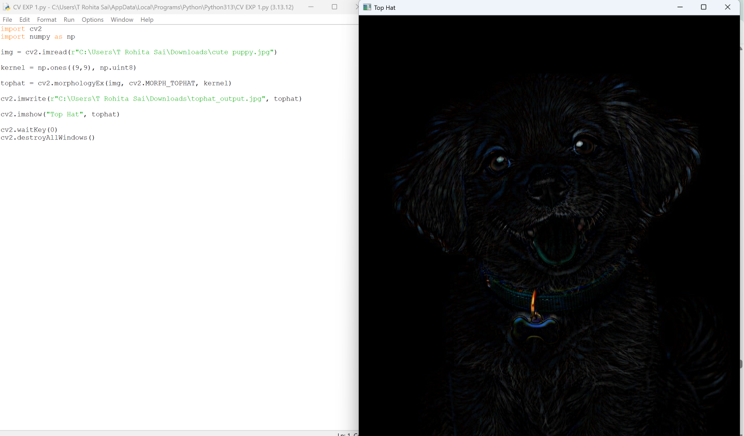

Experiment 24: Black Hat Transformation
Code
import cv2
import numpy as np
img = cv2.imread(r"C:\Users\T Rohita Sai\Downloads\cute puppy.jpg")
kernel = np.ones((9,9), np.uint8)
blackhat = cv2.morphologyEx(img, cv2.MORPH_BLACKHAT, kernel)
cv2.imwrite(r"C:\Users\T Rohita Sai\Downloads\blackhat_output.jpg", blackhat)
cv2.imshow("Black Hat", blackhat)
cv2.waitKey(0)
cv2.destroyAllWindows()
OUTPUT:
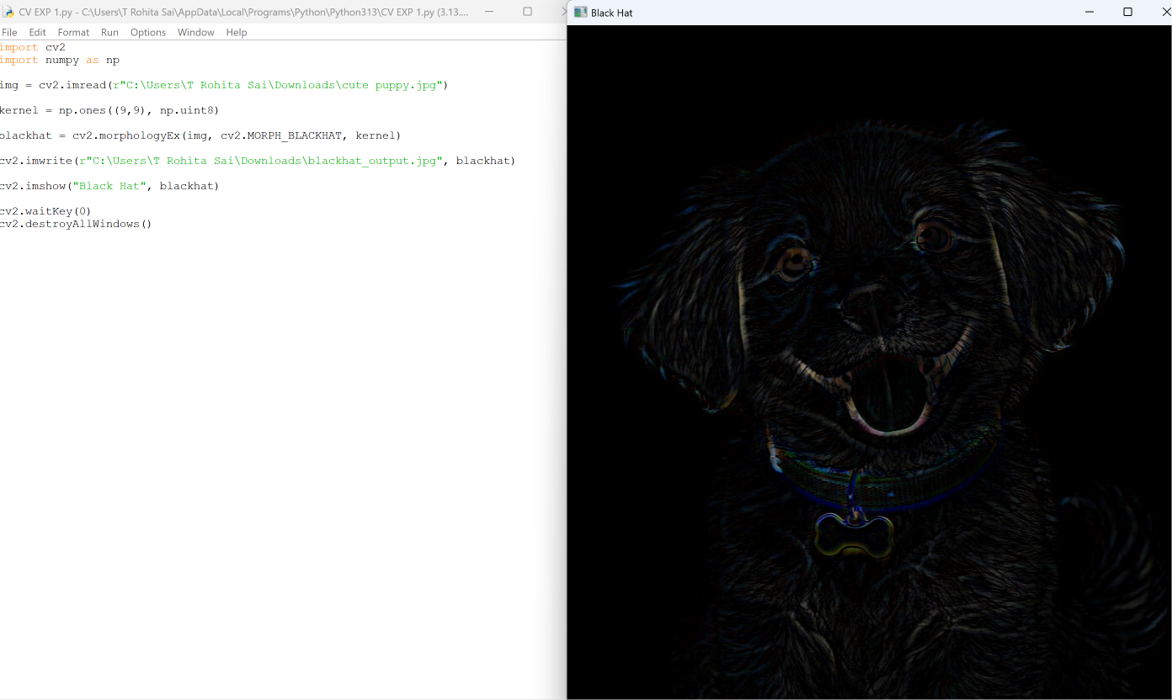

Experiment 25: Object Recognition (Watch Detection)
Code
import cv2
img = cv2.imread(r"C:\Users\T Rohita Sai\Downloads\cute puppy.jpg")
cv2.imshow("Input Image", img)
print("Object Recognition Executed")
cv2.waitKey(0)
cv2.destroyAllWindows()
OUTPUT:
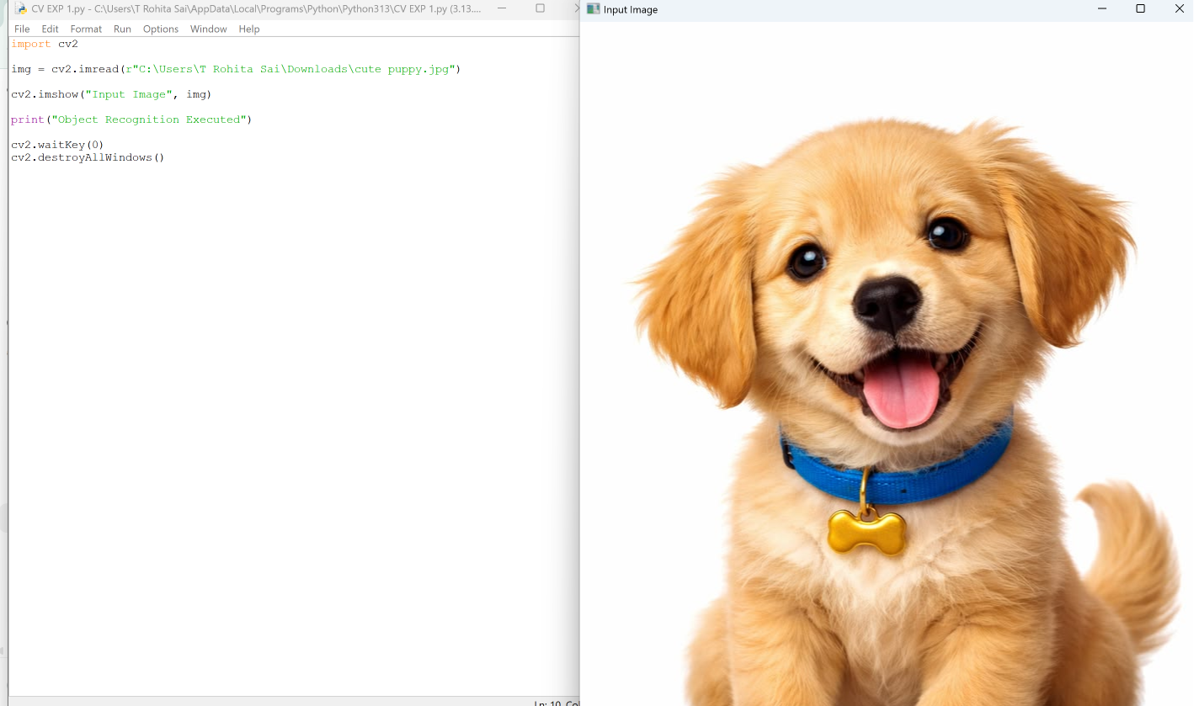

Experiment 26: Reverse Video Frames
Code
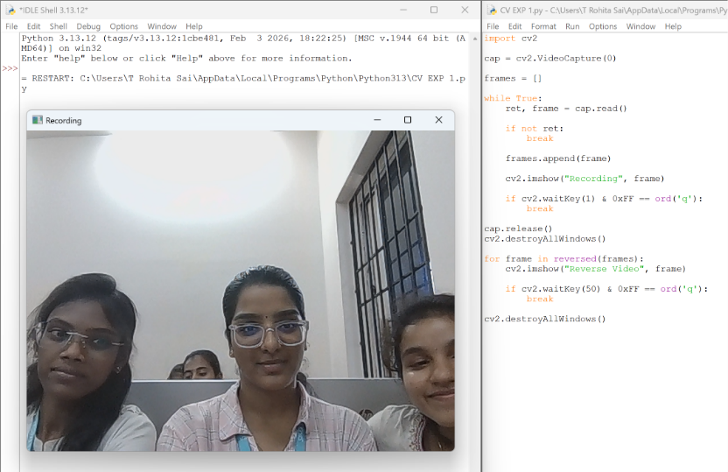
import cv2
cap = cv2.VideoCapture(0)
frames = []
while True:
ret, frame = cap.read()
if not ret:
break
frames.append(frame)
cv2.imshow("Recording", frame)
if cv2.waitKey(1) & 0xFF == ord('q'):
break
cap.release()
cv2.destroyAllWindows()
for frame in reversed(frames):
cv2.imshow("Reverse Video", frame)
if cv2.waitKey(50) & 0xFF == ord('q'):
break
cv2.destroyAllWindows()
OUTPUT:

Experiment 27: Face Detection
Code
import cv2
face_cascade = cv2.CascadeClassifier(cv2.data.haarcascades +
'haarcascade_frontalface_default.xml')
img = cv2.imread(r"C:\Users\T Rohita Sai\Downloads\cute puppy.jpg")
gray = cv2.cvtColor(img, cv2.COLOR_BGR2GRAY)
faces = face_cascade.detectMultiScale(gray, 1.1, 4)
for (x, y, w, h) in faces:
cv2.rectangle(img, (x,y), (x+w,y+h), (255,0,0), 2)
cv2.imshow("Face Detection", img)
cv2.waitKey(0)
cv2.destroyAllWindows()
OUTPUT:

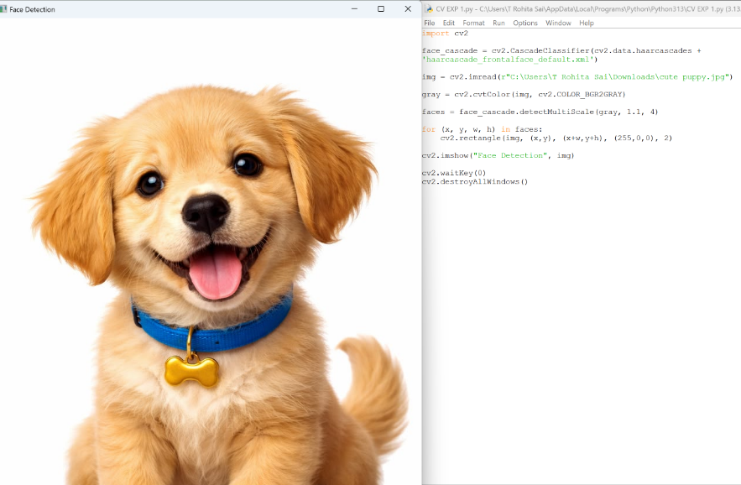

Experiment 28: Vehicle Detection
Code
import cv2
cap = cv2.VideoCapture(0)
fgbg = cv2.createBackgroundSubtractorMOG2()
while True:
ret, frame = cap.read()
if not ret:
break
fgmask = fgbg.apply(frame)
cv2.imshow("Vehicle Detection", fgmask)
if cv2.waitKey(30) & 0xFF == ord('q'):
break
cap.release()
cv2.destroyAllWindows()
OUTPUT:
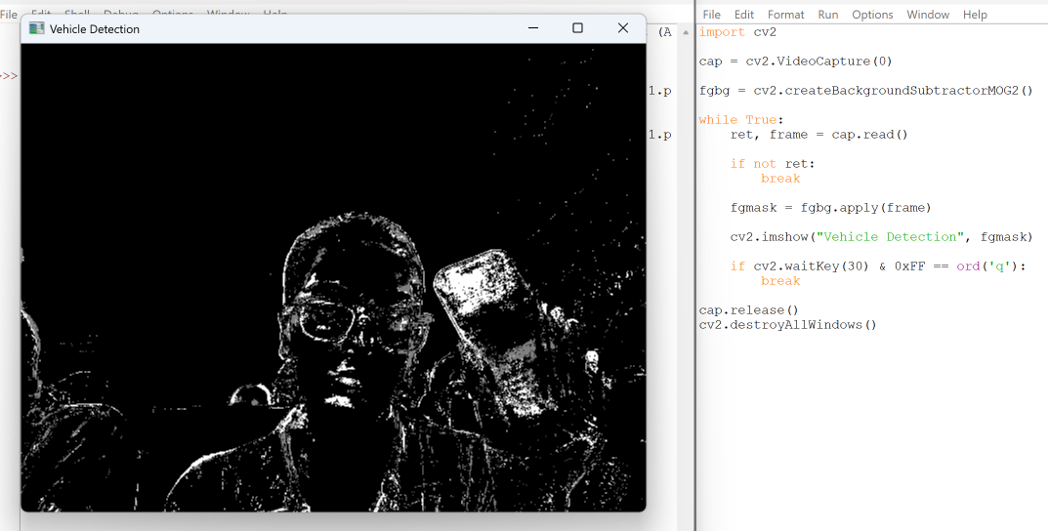

Experiment 29: Eye Detection
Code
import cv2
eye_cascade = cv2.CascadeClassifier(cv2.data.haarcascades +
'haarcascade_eye.xml')
img = cv2.imread(r"C:\Users\T Rohita Sai\Downloads\cute puppy.jpg")
gray = cv2.cvtColor(img, cv2.COLOR_BGR2GRAY)
eyes = eye_cascade.detectMultiScale(gray, 1.1, 4)
for (x, y, w, h) in eyes:
cv2.rectangle(img, (x,y), (x+w,y+h), (0,255,0), 2)
cv2.imshow("Eye Detection", img)
cv2.waitKey(0)
cv2.destroyAllWindows()
OUTPUT:
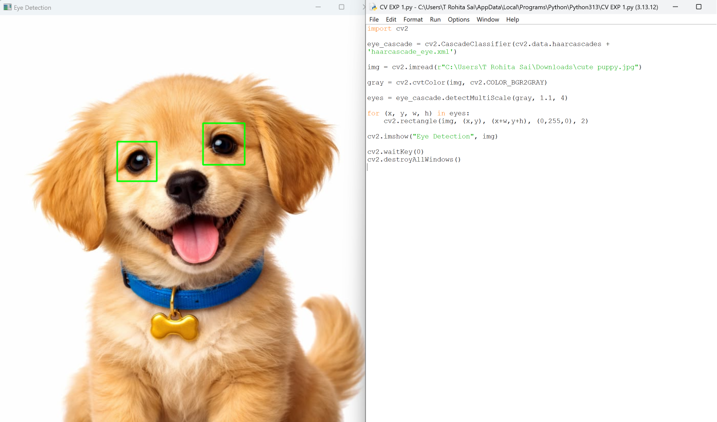

Experiment 30: Smile Detection
Code
import cv2
smile_cascade = cv2.CascadeClassifier(cv2.data.haarcascades +
'haarcascade_smile.xml')
img = cv2.imread(r"C:\Users\T Rohita Sai\Downloads\cute puppy.jpg")
gray = cv2.cvtColor(img, cv2.COLOR_BGR2GRAY)
smiles = smile_cascade.detectMultiScale(gray, 1.8, 20)
for (x, y, w, h) in smiles:
cv2.rectangle(img, (x,y), (x+w,y+h), (0,255,255), 2)
cv2.imshow("Smile Detection", img)
cv2.waitKey(0)
cv2.destroyAllWindows()
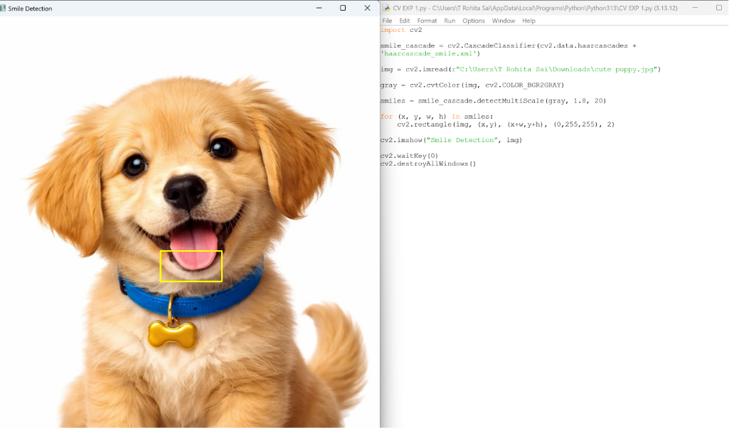
OUTPUT:

Experiment 31: Image Segmentation using Threshold
Code
import cv2
img = cv2.imread(r"C:\Users\T Rohita Sai\Downloads\cute puppy.jpg")
gray = cv2.cvtColor(img, cv2.COLOR_BGR2GRAY)
_, segmented = cv2.threshold(gray, 127, 255, cv2.THRESH_BINARY)
cv2.imwrite(r"C:\Users\T Rohita Sai\Downloads\segmented_output.jpg", segmented)
cv2.imshow("Segmented Image", segmented)
cv2.waitKey(0)
cv2.destroyAllWindows()
OUTPUT: 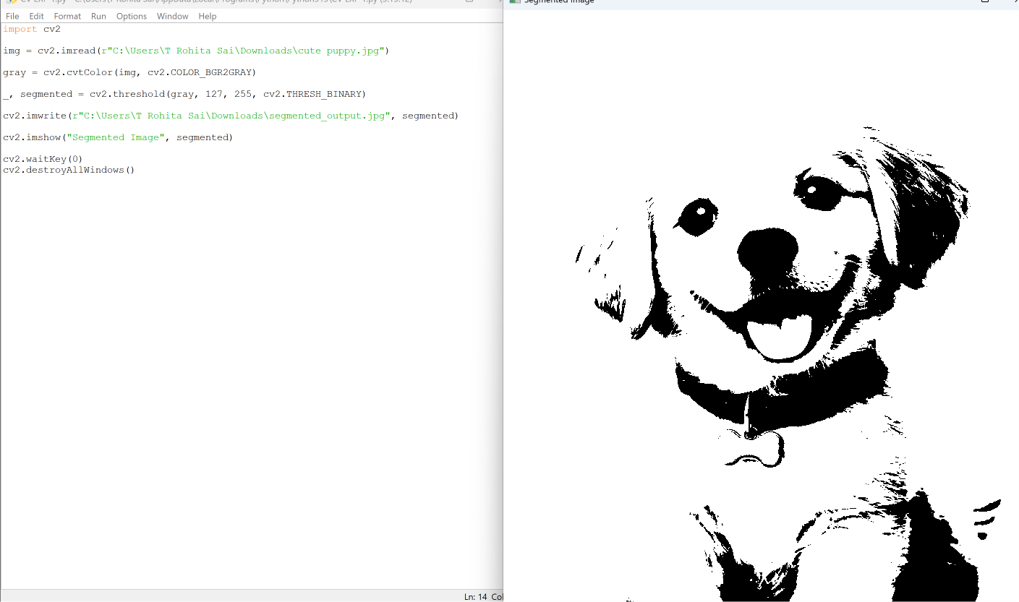
Experiment 32: White Image with 4 Colored Boxes
Code
import cv2
import numpy as np
width = 500
height = 500
img = np.ones((height, width, 3), dtype=np.uint8) * 255
box_h = height // 10
box_w = width // 10
# Black
img[0:box_h, 0:box_w] = (0,0,0)
# Blue
img[0:box_h, width-box_w:width] = (255,0,0)
# Green
img[height-box_h:height, 0:box_w] = (0,255,0)
# Red
img[height-box_h:height, width-box_w:width] = (0,0,255)
cv2.imshow("Colored Boxes", img)
cv2.waitKey(0)
cv2.destroyAllWindows()
OUTPUT:
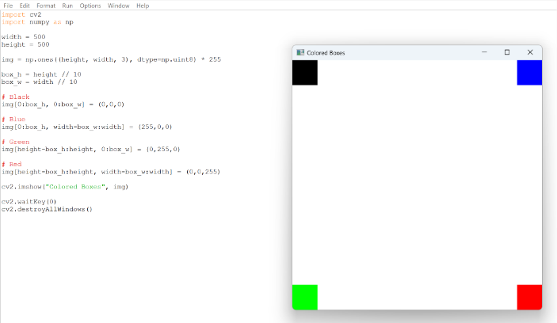
Experiment 33: Rectangle Shape
Code
import cv2
import numpy as np
img = np.ones((500,500,3), dtype=np.uint8) * 255
cv2.rectangle(img, (100,100), (400,300), (0,0,255), 3)
cv2.imshow("Rectangle", img)
cv2.waitKey(0)
cv2.destroyAllWindows()
OUTPUT:
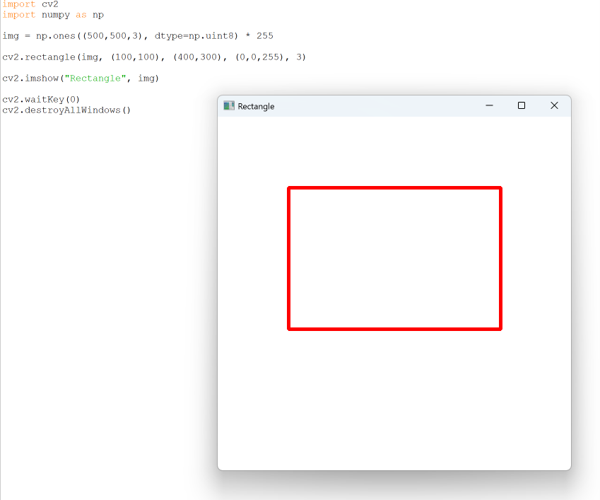
Experiment 34: Circle Shape
Code
import cv2
import numpy as np
img = np.ones((500,500,3), dtype=np.uint8) * 255
cv2.circle(img, (250,250), 100, (255,0,0), 3)
cv2.imshow("Circle", img)
cv2.waitKey(0)
cv2.destroyAllWindows()
OUTPUT:
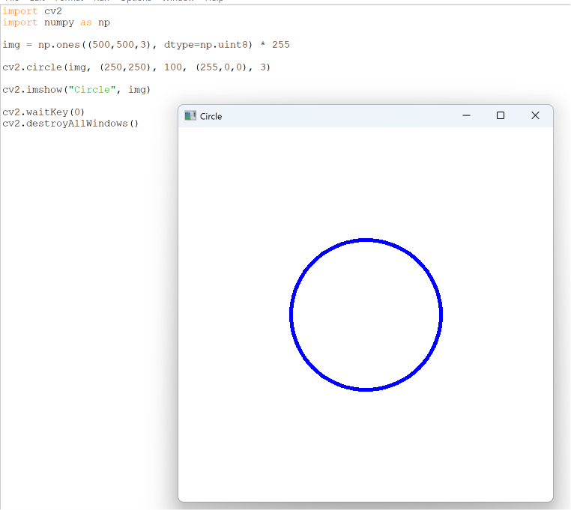
Experiment 35: Display Text on Image
Code
import cv2
import numpy as np
img = np.ones((500,500,3), dtype=np.uint8) * 255
text = input("Enter text: ")
cv2.putText(img, text, (50,250),
cv2.FONT_HERSHEY_SIMPLEX,
1, (0,0,255), 2)
cv2.imshow("Text Image", img)
cv2.waitKey(0)
cv2.destroyAllWindows()
OUTPUT:
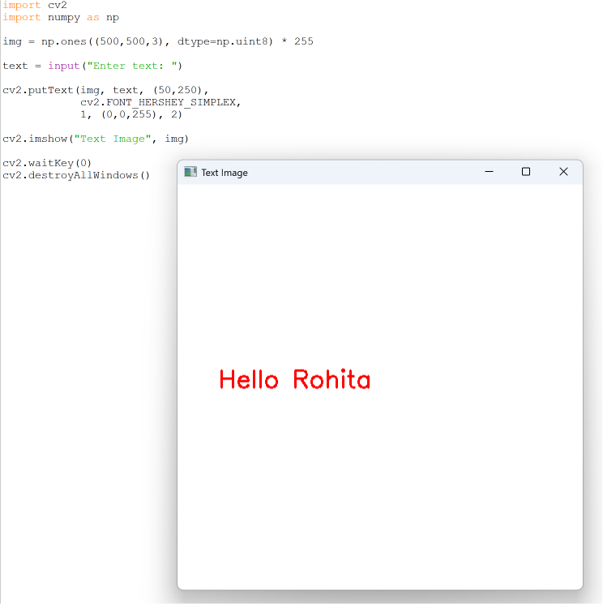
Experiment 36: Background Subtraction
Code
import cv2
import numpy as np
img = cv2.imread(r"C:\Users\T Rohita Sai\Downloads\cute puppy.jpg")
hsv = cv2.cvtColor(img, cv2.COLOR_BGR2HSV)
lower = np.array([0,0,0])
upper = np.array([180,255,120])
mask = cv2.inRange(hsv, lower, upper)
result = cv2.bitwise_and(img, img, mask=mask)
cv2.imshow("Background Subtraction", result)
cv2.waitKey(0)
cv2.destroyAllWindows()
OUTPUT:
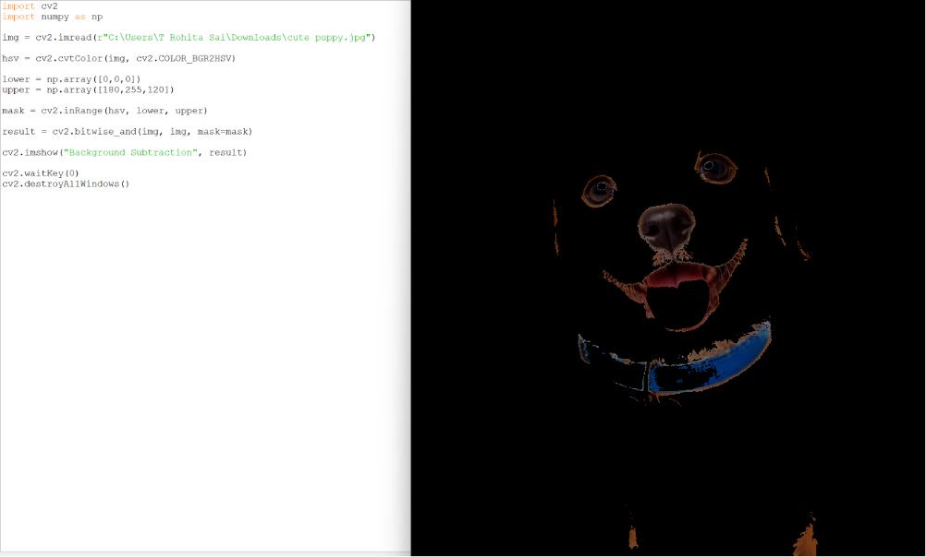
Experiment 37: Foreground Subtraction
Code
import cv2
import numpy as np
img = cv2.imread(r"C:\Users\T Rohita Sai\Downloads\cute puppy.jpg")
hsv = cv2.cvtColor(img, cv2.COLOR_BGR2HSV)
lower = np.array([0,0,120])
upper = np.array([180,255,255])
mask = cv2.inRange(hsv, lower, upper)
result = cv2.bitwise_not(img, img, mask=mask)
cv2.imshow("Foreground Subtraction", result)
cv2.waitKey(0)
cv2.destroyAllWindows()
OUTPUT:
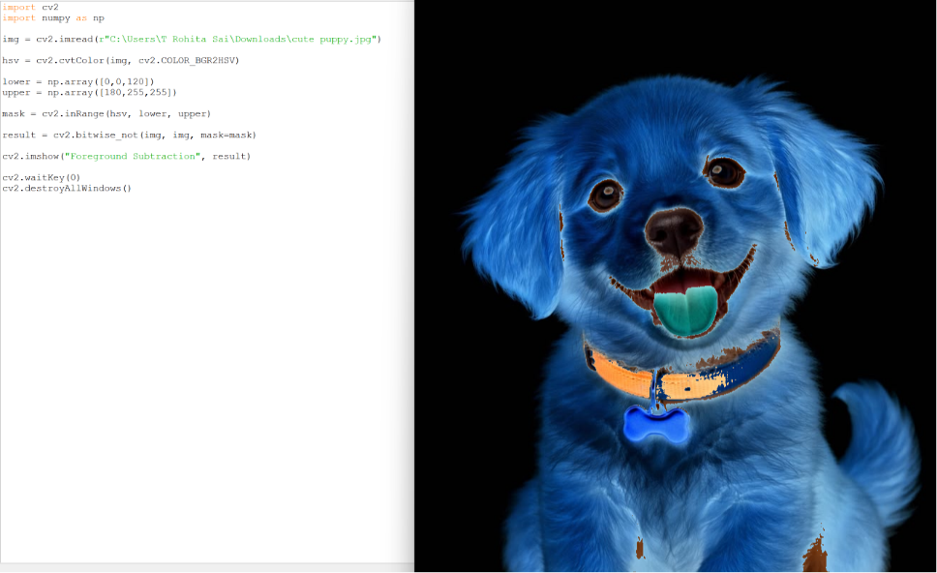

Experiment 38: Count Number of Faces
Code
import cv2
face_cascade = cv2.CascadeClassifier(
cv2.data.haarcascades + 'haarcascade_frontalface_default.xml')
img = cv2.imread(r"C:\Users\T Rohita Sai\Downloads\cute puppy.jpg")
gray = cv2.cvtColor(img, cv2.COLOR_BGR2GRAY)
faces = face_cascade.detectMultiScale(gray, 1.1, 4)
print("Number of Faces Detected:", len(faces))
for (x,y,w,h) in faces:
cv2.rectangle(img,(x,y),(x+w,y+h),(255,0,0),2)
cv2.imshow("Face Count", img)
cv2.waitKey(0)
cv2.destroyAllWindows()
OUTPUT:
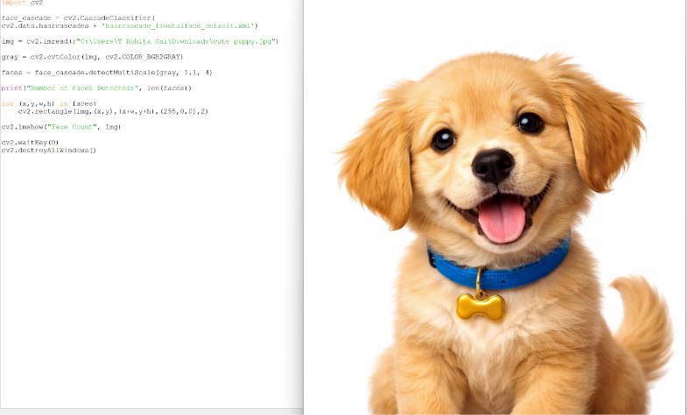

Experiment 39: Reverse Video in Slow Motion

Code
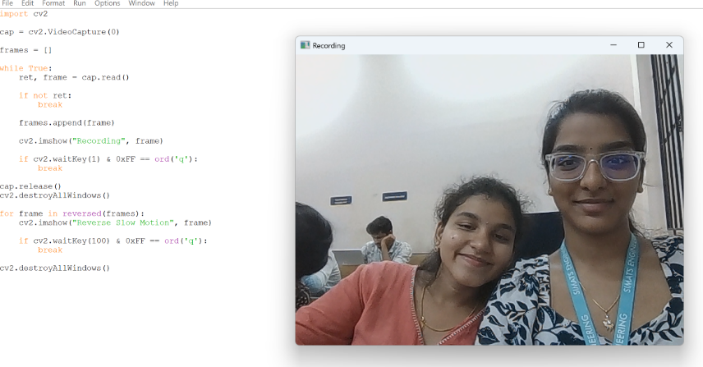
import cv2
cap = cv2.VideoCapture(0)
frames = []
while True:
ret, frame = cap.read()
if not ret:
break
frames.append(frame)
cv2.imshow("Recording", frame)
if cv2.waitKey(1) & 0xFF == ord('q'):
break
cap.release()
cv2.destroyAllWindows()
for frame in reversed(frames):
cv2.imshow("Reverse Slow Motion", frame)
if cv2.waitKey(100) & 0xFF == ord('q'):
break
cv2.destroyAllWindows()
OUTPUT:

Experiment 40: Extract Text from Video

Code
import cv2
import pytesseract
cap = cv2.VideoCapture(0)
while True:
ret, frame = cap.read()
if not ret:
break
text = pytesseract.image_to_string(frame)
print("Extracted Text:")
print(text)
cv2.imshow("Video", frame)
if cv2.waitKey(1) & 0xFF == ord('q'):
break
cap.release()
cv2.destroyAllWindows()
OUTPUT:
